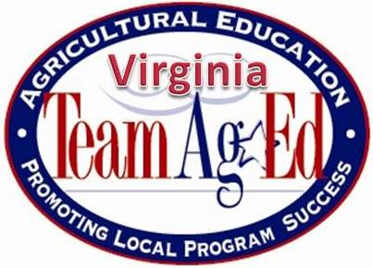
Hillison Early Career Ag Teachers’ Conference
Enhancing Teacher Practice to Support the
3-Circle Model of Ag Education
In partnership with the VAAE Winter Conference
January 15 – 16, 2026
Blue Ridge Community College
Weyers Cave, VA 24486

Thursday, January 15th

9:30 – 10:00 am Registration – Snacks & Hot Beverages will be available

10:00 am – 12:00 pm Classroom Instruction - How do we help students become excited about our
courses? Each session will include materials teachers can take home
and use in their classes!

12:30 – 1:00 pm Lunch

1:00 – 4:00 pm Paperwork – What Paperwork?? What paperwork will you need to make sure
You keep track of it as you move through the spring semester and
into the summer

Classroom Instruction Resources Based On Your Requests

4:00 – 4:15 pm Break

4:30- 5:00 pm FFA Teacher Ambassadors – Introduction to Educator Resources on ffa.org

5:00 – 6:30 pm Dinner & Chalk-Talk & Small Group Discussions to address the
biggest current issues people are experiencing in their classrooms

7:00 – 9:30 pm Optional Agricultural Mechanics Workshop to Support Licensure
Requirements

Friday, January 16th

8:30 – 11:30 am National Chapter Award Applications – They Begin with a
Program of Activities!

Building Relationships with Colleagues and Community Members

11:30 – 12:30 pm Lunch to go. Please travel to the Opening of the Winter Conference.

